Animal testing - the facts

What do you think about testing medicines on animals?
Science can be full of difficult decisions...
Scientists who design drugs and other medical treatments have to make difficult decisions about testing drugs on animals. Planet Science investigates the facts.
Why do animal testing?
- It's the law! All drugs have to be tested on animals before they can be tested on humans
- To make sure human patients are given a safe dose of a drug.
- Patients feel safe and are more likely to trust medicines if they know they have been tested on animals first.
Why introduce alternatives to animal testing?
- Humans and animals don't always react in the same way to a drug. One drug, TGN1412, was tested on animals and in humans. All the human patients suffered life-threatening side-effects which didn't appear in animals.
- Not all drugs are used for the original purpose they were designed for. Animal testing can't show all the potential uses of a drug.
- Ethical considerations - is it morally right to test all medicines on animals first?
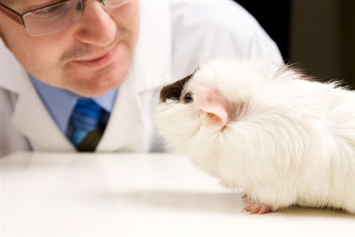
Have scientists developed any alternatives to animal testing?
Yes! Some of these are currently being used alongside animal testing. For example, some scientists are using synthetic skin to measure how drugs travel through the skin. Other scientists use human cell cultures to test how drugs work.
Do animal based experiments produce useful results?
It depends who you ask!
YES: Life support machines, dialysis, and asthma drugs have all been produced using animal testing.
NO: All the research which used animal testing in the EU was investigated recently. The investigators found that animal testing generally has a high scientific value, but that very few animal testing trials have a high medical benefit.
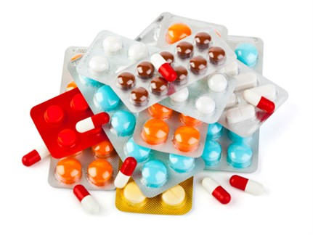
Can we remove animal testing from the pharmaceutical industry?
At the moment it's the law that all medical drugs are tested on animals, so the law would need to be changed. Perhaps the law could be changed so that animal testing was optional, rather than compulsory. Scientists could decide not to test drugs on animals if they knew that it was safe to do so.
We would need alternatives to animal testing, which could safely test drugs without harmful consequences for humans. Animal testing alternatives are being developed in universities and laboratories across the country.
Do you think we will ever be able to replace animal testing with these alternatives? Should animal testing be optional, not compulsory? You decide!

fake
the artificial process of eliminating (getting rid of) waste and unwanted water from the blood
obligatory; required

