Name: Section: ___________ Date: ___________

Writing Introductions

Introductions should…
- Introduce your readers to the topic of your essay
- Contain your thesis statement (claim)
- Show how your claim will be developed or proven

There are 2 general ways that you can write an introduction:

Method #1:
The easiest and simplest way is for you to write your thesis statement followed by all of your topic sentences (reasons).

Make a clear claim/thesis.
- It is clear that…
- I believe that…
- I strongly think that…

Briefly explain your reasons.

Method #2
Another way that you could write your introduction is by using an "inverted pyramid structure." This is called an inverted pyramid because your introduction would begin with a broad and general statement and get more specific as it continued on.
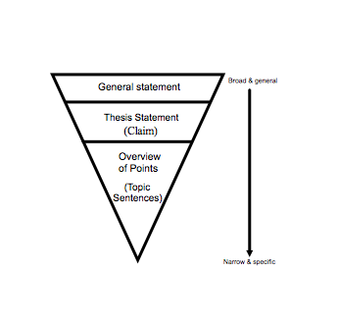

Give any relevant background/context on the issue for those who may be unfamiliar with the topic. Describe the problem/issue.
- An issue that is hotly debated is….
- … is a highly contested topic.
- There has long been disagreement about...
- Some think….but others…

Make a clear claim.
- It is clear that…
- Research shows, hover, that…
- I believe that…

Briefly explain your reasons.

Example: Recently, there has been a tremendous amount of controversy surrounding the regulation of electronic cigarettes. Electronic cigarettes, also known as e-cigarettes, are battery-powered devices used to simulate tobacco smoking; however, unlike traditional cigarettes, they do not contain tobacco. Some people claim that this is a good enough excuse to condone the sale of e-cigarettes, but what they may not know is the harm that this product can cause to smokers and non-smokers alike. E-cigarettes should be banned – they are harmful to non-smokers and smokers alike and can cause nicotine addictions in teens.

Writing Conclusions

Conclusions should…
- Re-state and/or defend your claim (thesis)
- Give the essay a sense of completeness
- Leave a strong final impression on the reader

There are two different ways that you can write your conclusion as well.

Method #1
Write a simple summary. Acknowledge both sides, then restate and defend your claim and reasons.

Example: Critics of school uniforms claim that uniforms limit creativity and that they can be expensive. Even though this may be true in some cases, the ultimate fact is that the benefits of wearing a uniform outweigh its disadvantages. School uniforms are an extremely beneficial for students and for families. It reduces bullying, creates more focus on academics, and fosters a sense of school spirit and pride.

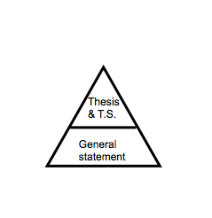
Method #2
Use pyramid structure, which is the opposite of the inverted pyramid. After you have acknowledged both sides and summed up the ideas in your essay (your claim and reasons), you can end with a more general statement that shows how the topic of your essay applies to the wider world.

For your last couple of lines (your general statement), you could:

- Call your readers to action…
Example: It is evident that year-round schooling is not the best option for the school calendar. There is absolutely nothing wrong with the traditional school year. Why change something that works so well? The final bell rings. Let’s make sure this bell means that the “real” summer vacation has come.

- Ask your readers to look to the future….
Example: Without well-qualified teachers, schools are little more than buildings and equipment. If higher-paying careers continue to attract the best and the brightest students, there will not only be a shortage of teachers, but the teachers available may not have the best qualifications. Our youth will suffer. And when youth suffers, the future suffers.

- Give the reader something to think about/ending with a powerful statement...
Example: Competitive sports are not all they are made out to be. They can ruin your future and the way you view yourself. The injuries are endless and the pain of failure never seems to lessen. Sports have caused many to look in the mirror and question whether or not the goal was worth a broken leg or if the home run was worth the concussion or if signing up for this "life changing activity" was worth the self doubt and hatred. We all have to take Alfie Kohn's wise words into consideration, "Having fun doesn't mean turning playing fields into battlefields."

